**Game Aesthetic**

Theme References

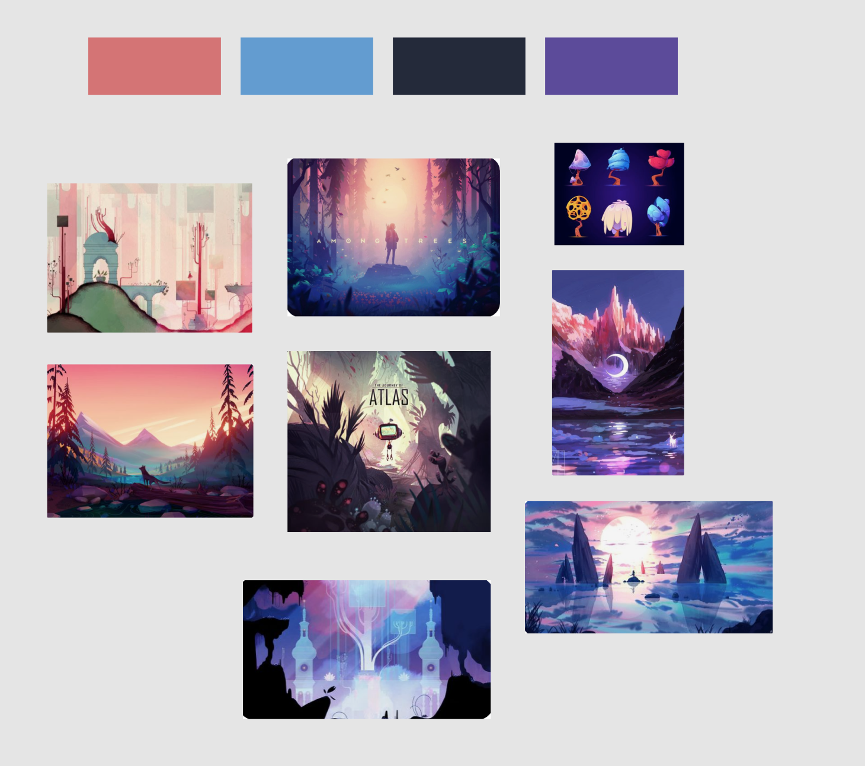

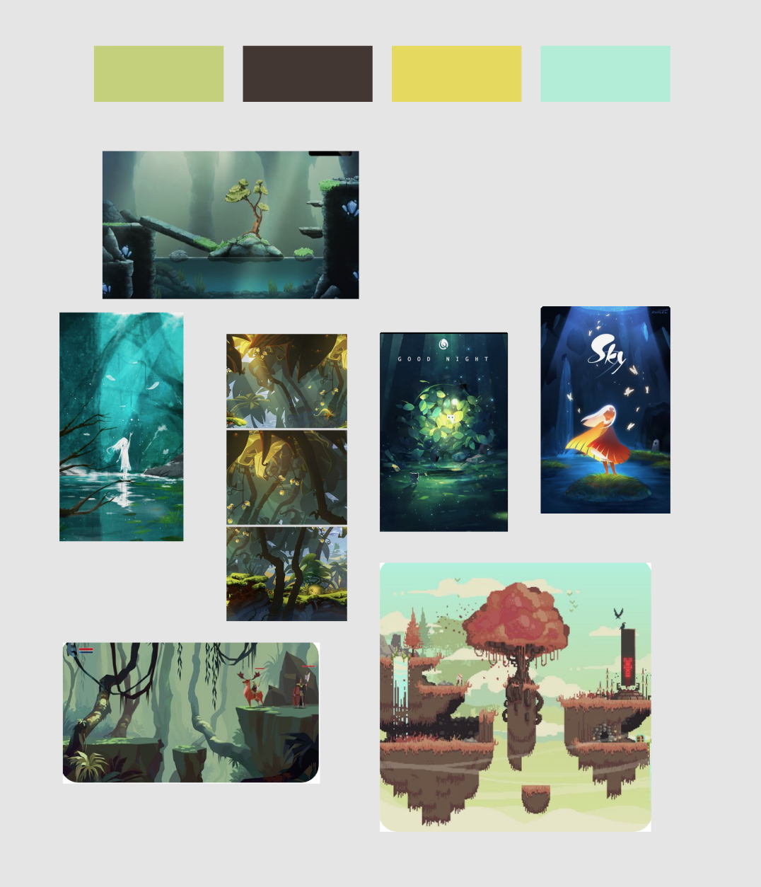

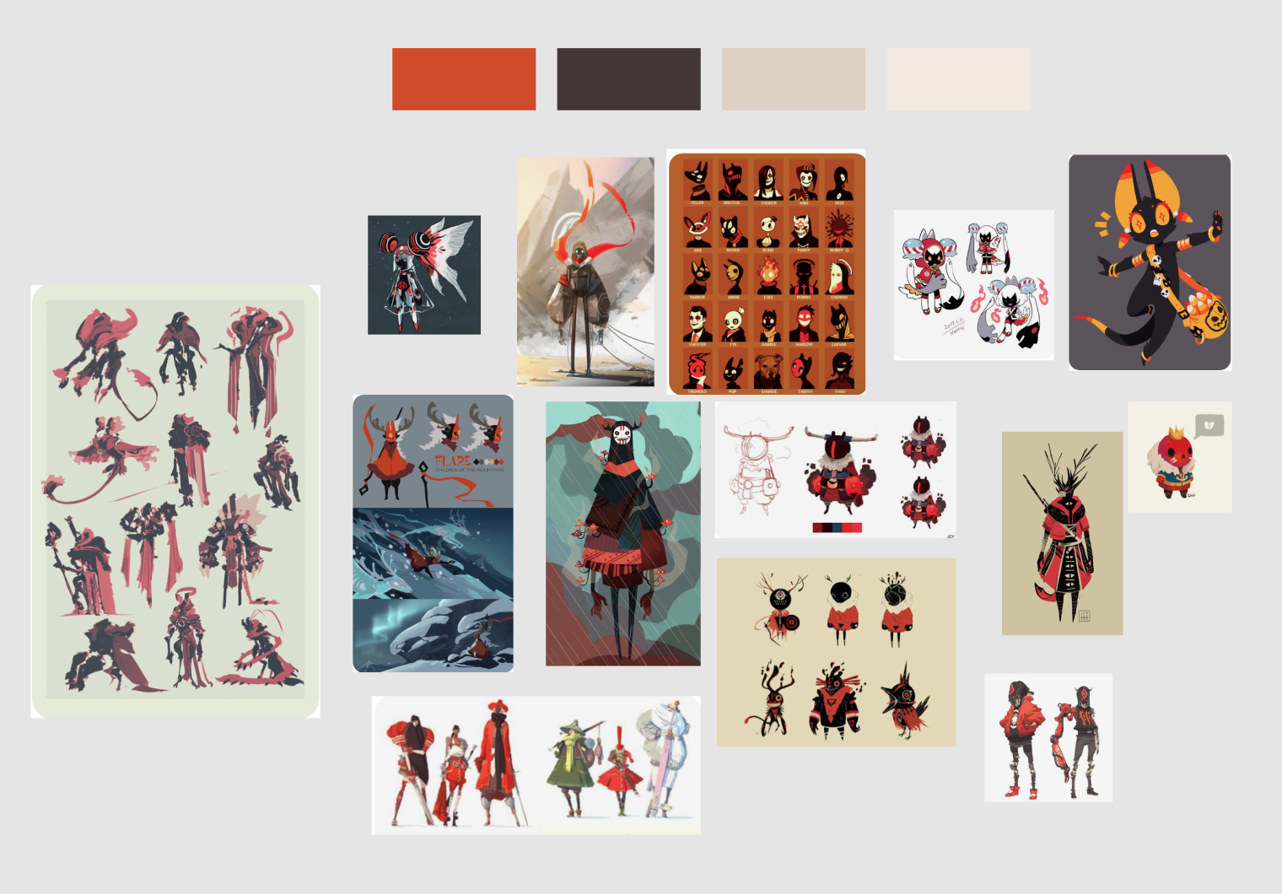

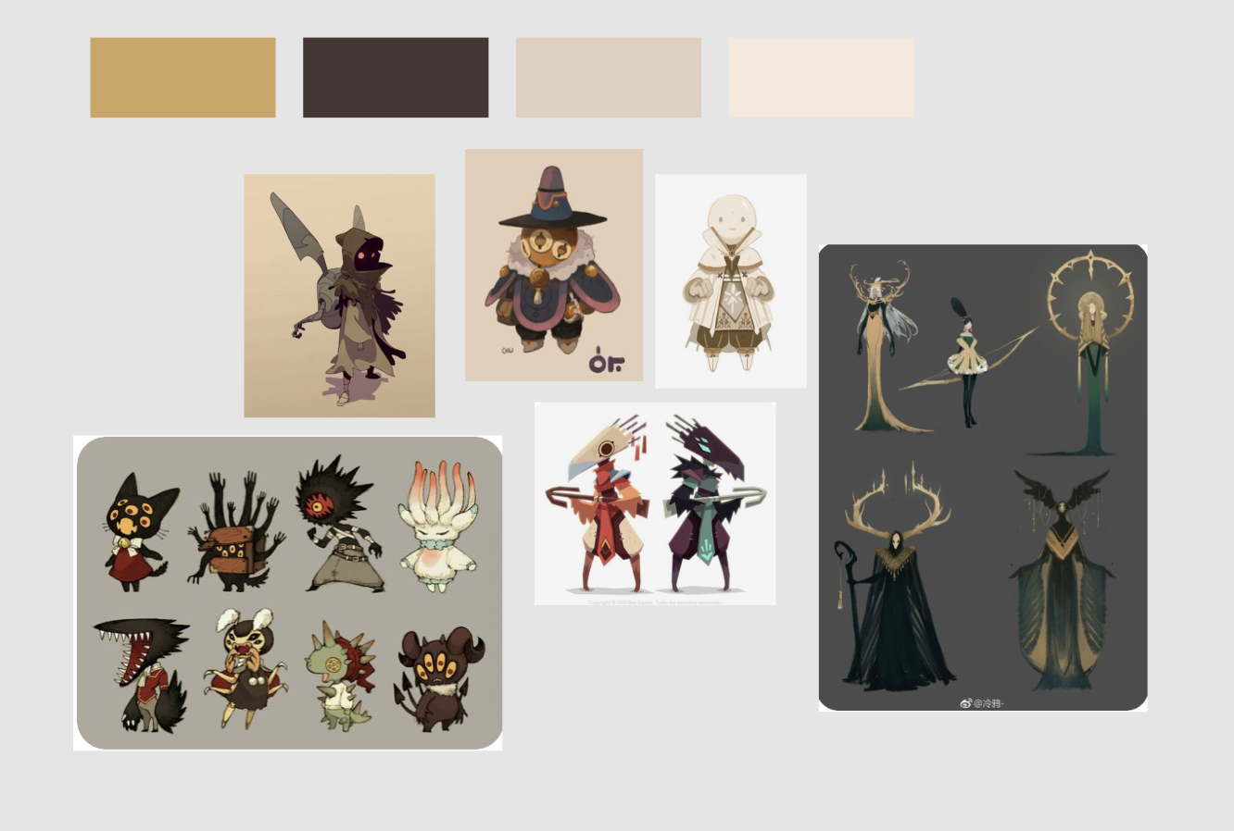

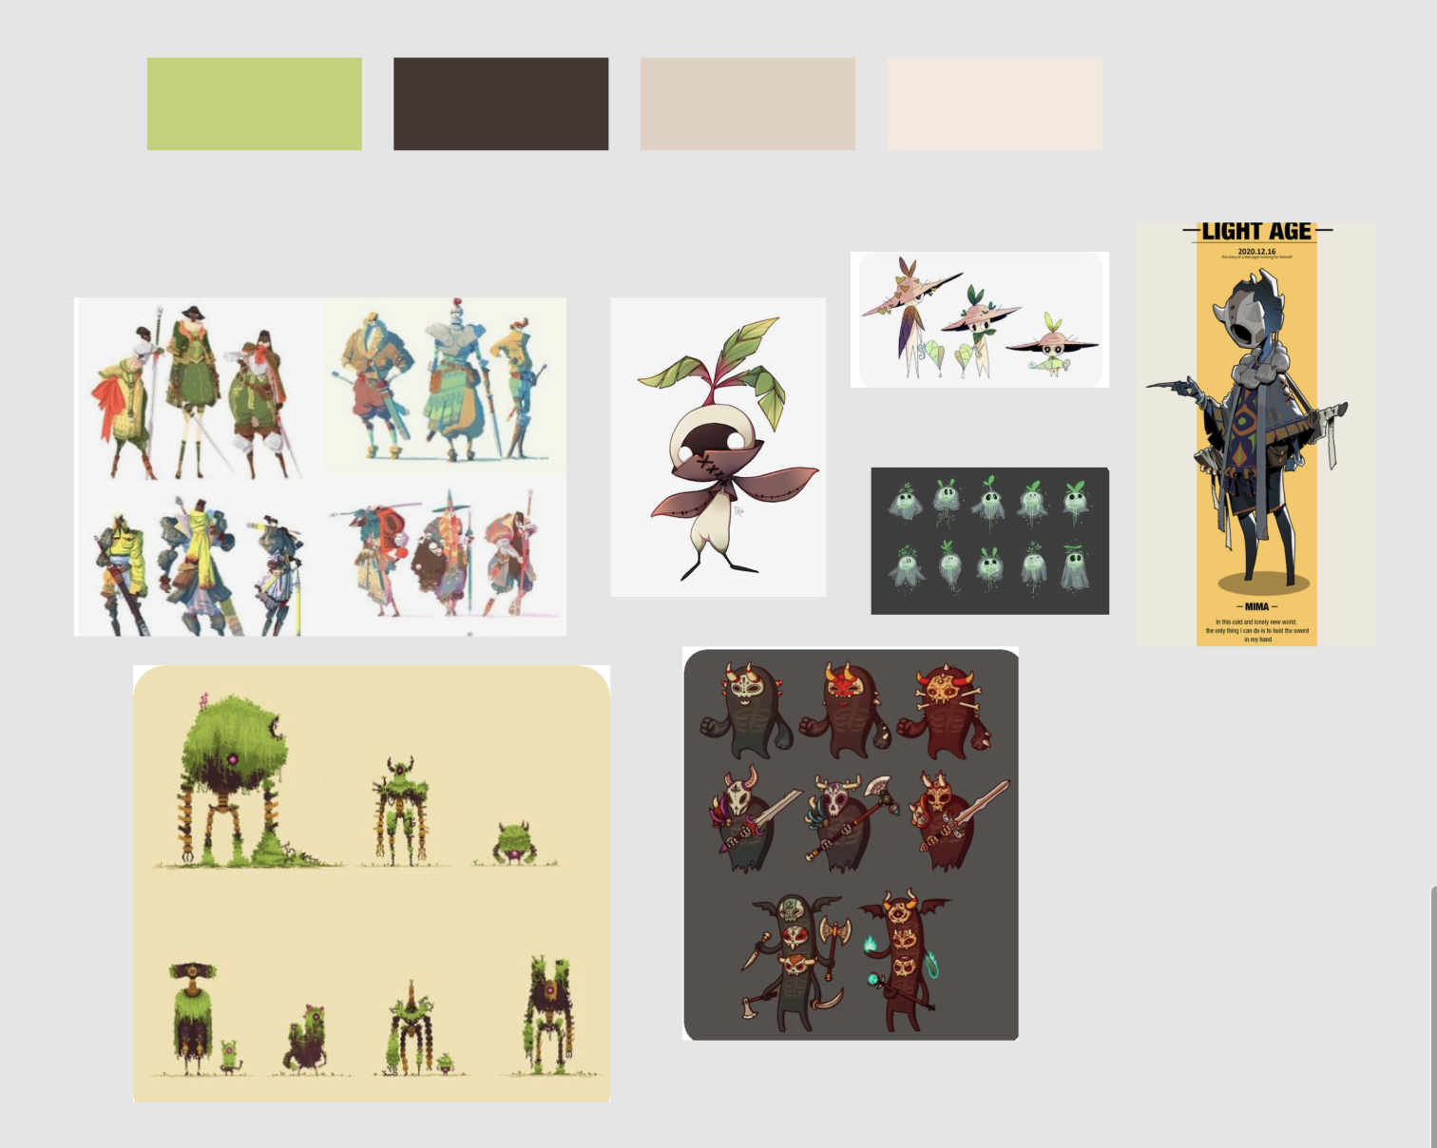

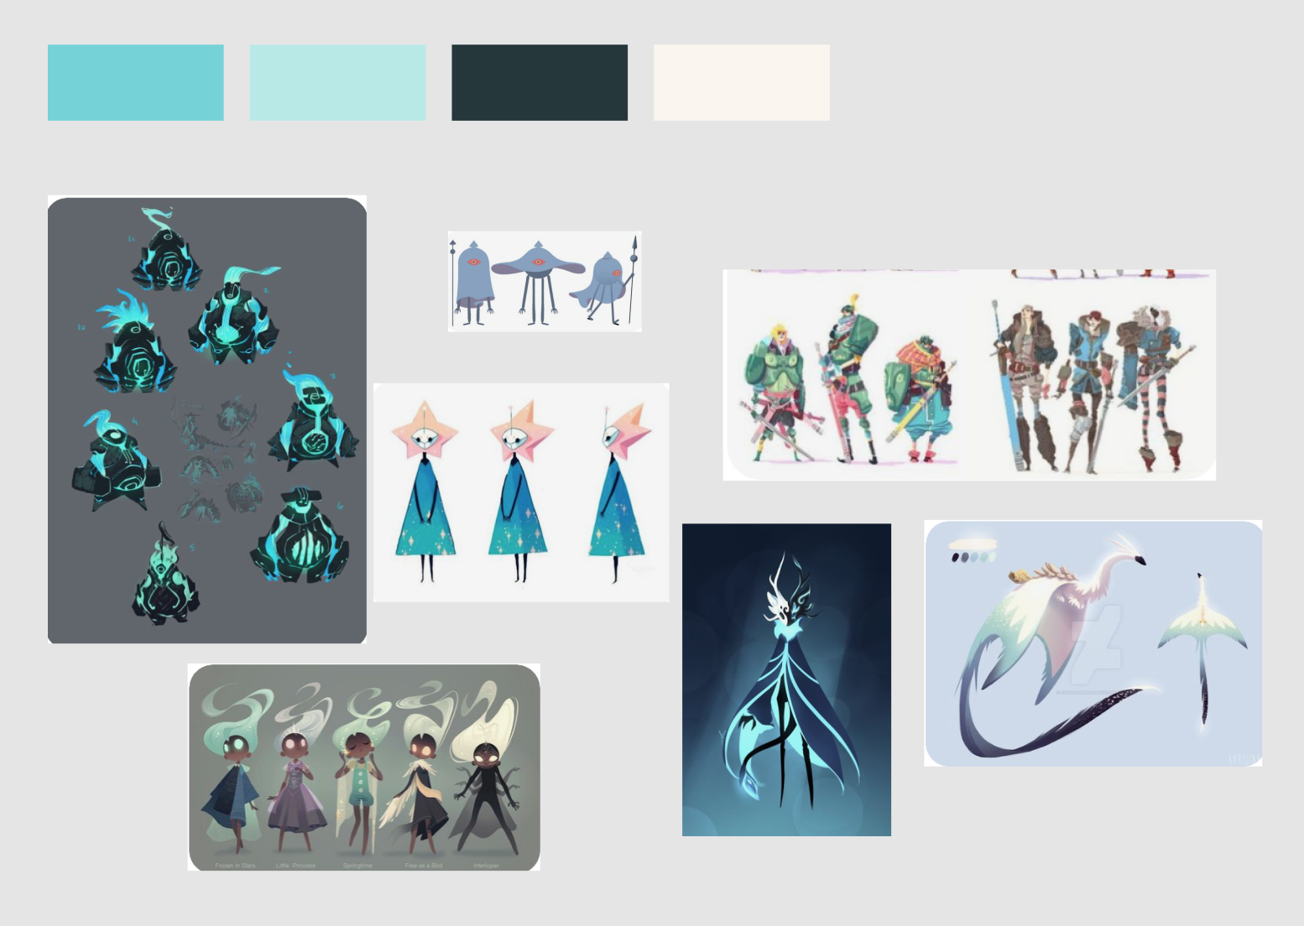

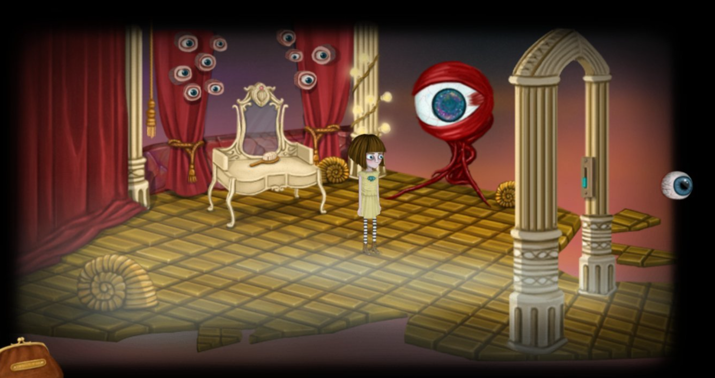

<https://adventuregamers.com/screenshots/view/24881>

Beginning

* Fantasy exploration, imaginary
* Genshin vibe

Towards the end

* Broken & warped, scattered, disintegrating
* Things are where it shouldn’t be